Guideline for abstracts prepared for Bioelectrics 2016

12th – 15th September, 2016 Rostock, Germany (Times 14, bold, centred)

A. Firstauthor¹, B. Secondauthor¹, C. Thirdauthor², D. Andso¹ (Times 12, normal, centred)

¹Bioelectrics Research Center, Leibniz Institute for Plasma Science and Technology (INP Greifswald), Felix-Hausdorff-Str. 2, 17489 Greifswald, Germany E-mail: Toto@address.com (Times 10, Italic, centred)
²SwitzerlandReplace this text with 2nd author’s affiliation

Include in this space a very short résumé of the abstract. Use Times New Roman font, 10 pt. Justified left and right. For title, authors name and affiliations, margins are 2.5 cm left and 2.5 cm right and for résumé 3.5 cm left and right.

1. General (Times 11, bold)
Contributed papers must be in English and should report previously unpublished works. The total length, including figures and references, is one A4 format page. The authors are responsible for the content and style of the contribution and no editing or retyping will be carried out by the Conference organisers. The accepted contributions will be reproduced without reduction or modification. Contributed papers which do not conform to the format described below may be rejected. Each abstract should be submit separately in electronic form at the e-mail address:
bioelectrics@bioelectrics2016.org
The submitted file must be both a Portable Document Format (.PDF) and a source file – either a LATEX (.TEX) or Text File (.RTF or .DOC(X)). If you use equations in your abstract, we recommend to prepare the abstract in the LATEX format.
All contributed papers will be refereed by the International Scientific Committee (ISC). Based on their scientific quality, they may be rejected. The ISC will also select a limited number of the accepted contributions for an oral presentation. A book of proceedings, containing abstracts of the invited talks, as well as all one page accepted abstracts, will be distributed to the participants on their arrival to the conference site.
Deadline for receipt of one page abstracts is 15th May, 2016!

2. Recommendations for the text
2.1. Format
For invited and contributed papers, the abstract should be typewritten for A4 format paper, using two columns Times New Roman font (exactly according to the present template). Margins are:
Top, Bottom: 2.5 cm; Left and Right: 2 cm.
Distance between columns: 0.5 cm.
Fonts must be:
Title: Times 14, Bold, centred
Authors names: Times 12, normal, centred
Affiliations: Times 10, Italic, centred

Main text: Times 11, justified in left and right
Figure and table captions: Times 10, italic (except the word ”Fig.” or ”Tab.” and the corresponding number), centered
Major headings (Times 11, bold) and subheadings (Times 10, bold) are placed flush on the left-hand margin on a separate line.

2.3. Figures, tables and equations
Abstracts may include figures and tables. A caption should be attached to each of them. The captions are shown here:

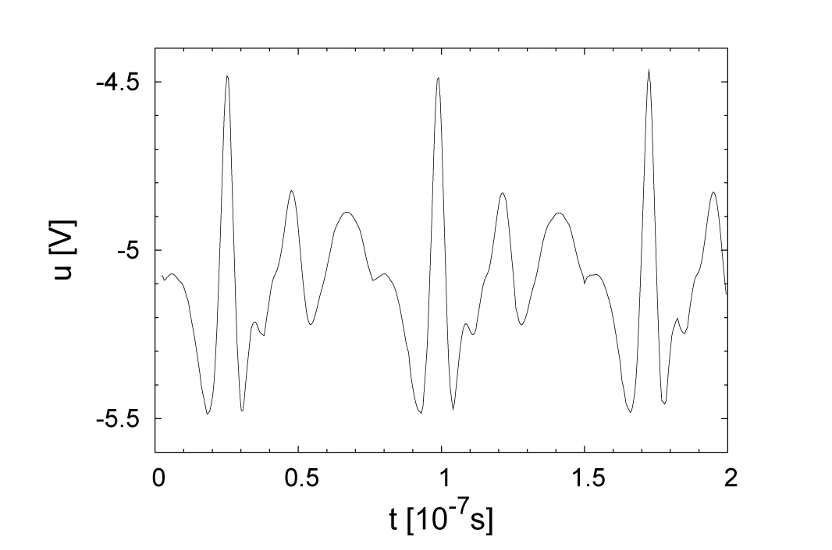
Fig. 1: A caption to this figure.

Tab. 1: A caption to a table.

Equation numbers must be in parentheses and placed flush with right-hand margin of the column.

References
[1] T.O. Seeyou, I.N. May, I.N. Rostock: Hop. For. Success 9 (2016), 8.

List and number all references at the end of the paper. When referring to them in the text, type the corresponding reference number between brackets as shown at the end of this sentence (automatic in LaTeX) [1].

